How to set up a PowerPoint slide for an academic poster
- Open up a new PowerPoint file in the Desktop or Web Version.
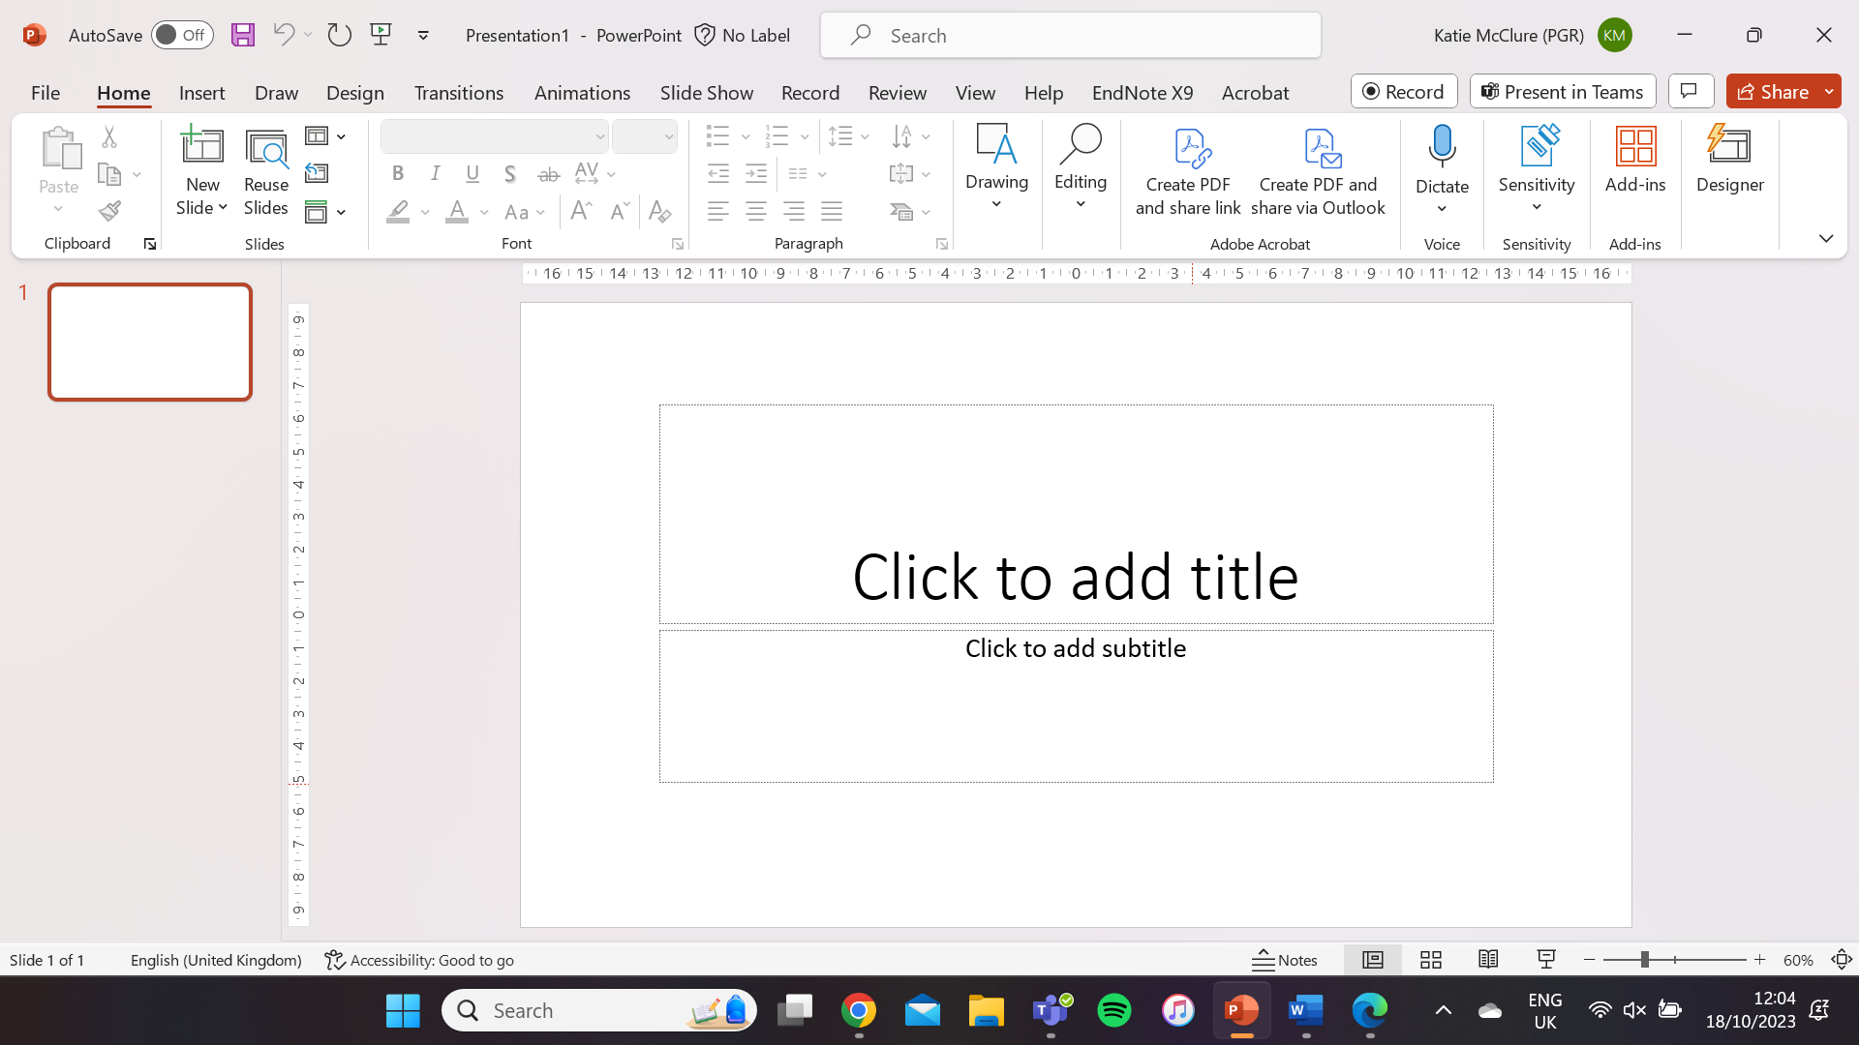 | 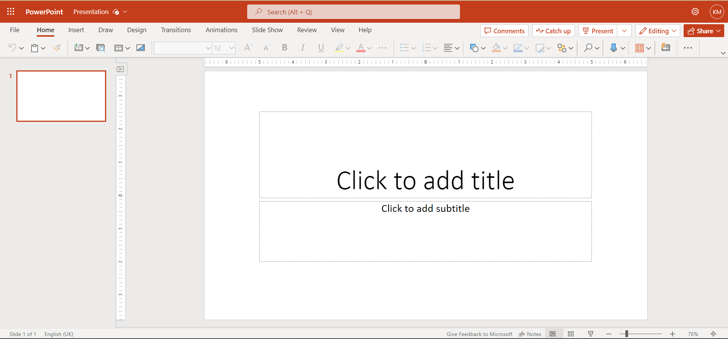
Desktop Version View | Web Version View

- Click the Design tab to open the design ribbon.
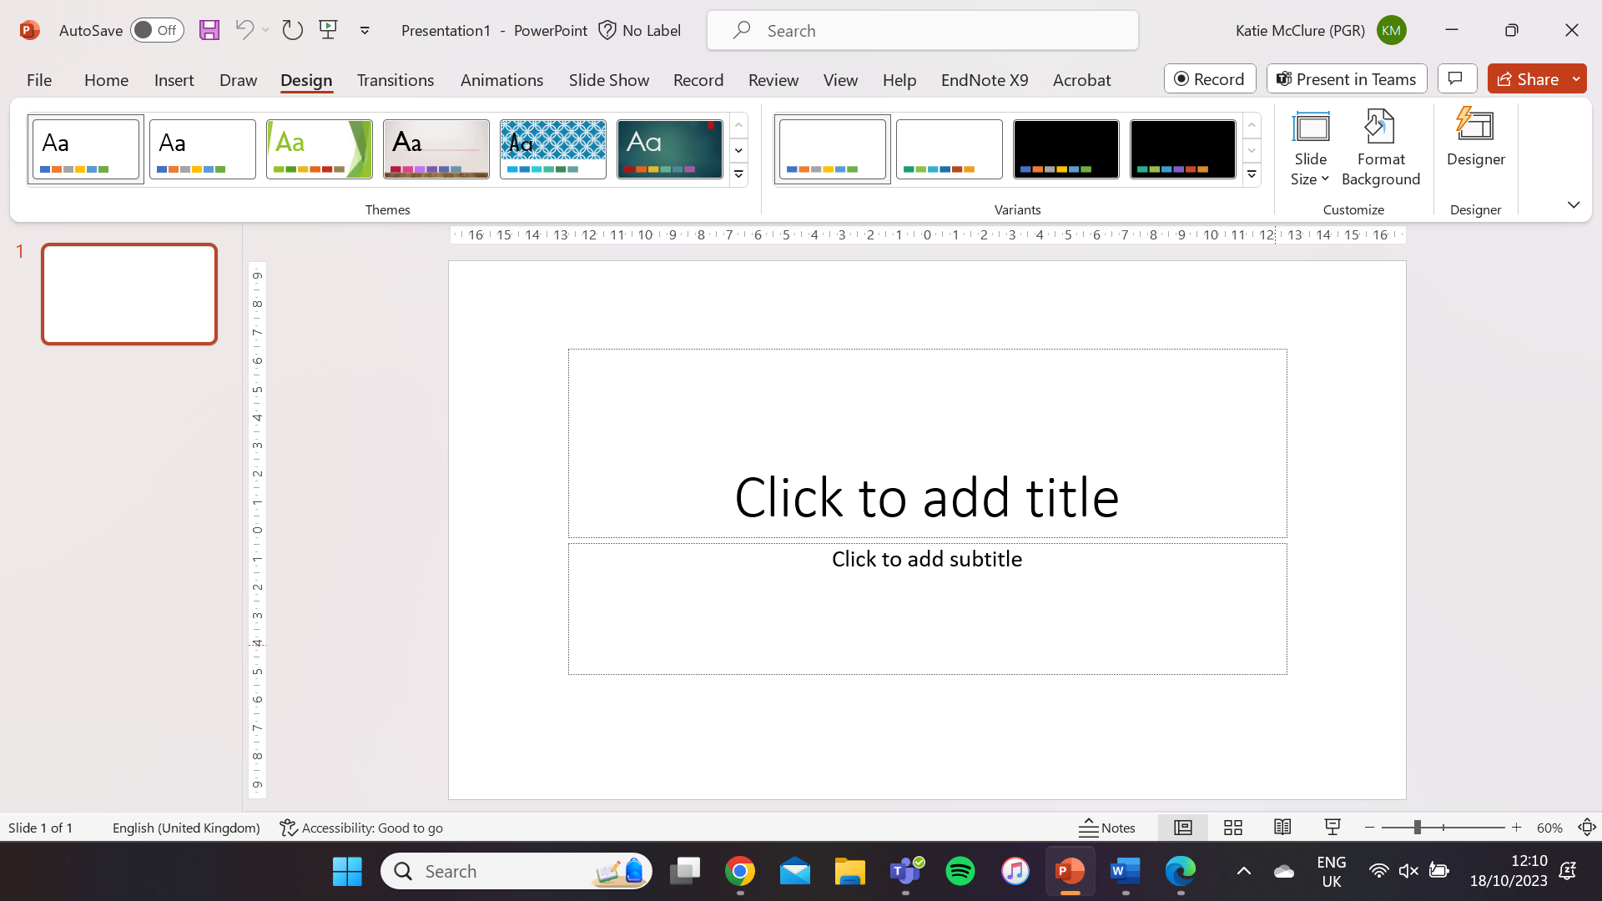 | 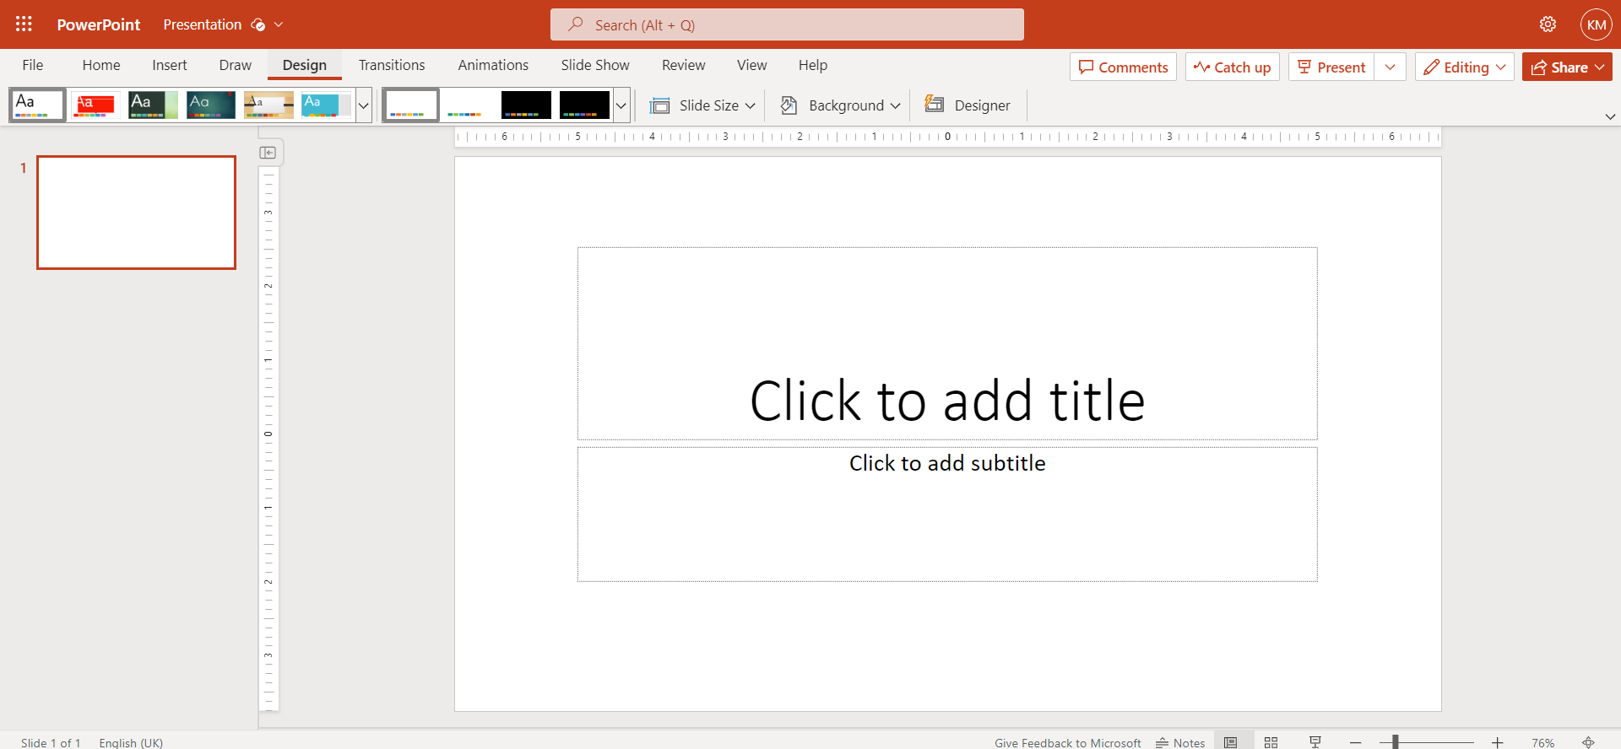
Desktop Version View | Web Version View

- Select Slide Size and Custom Slide Size.
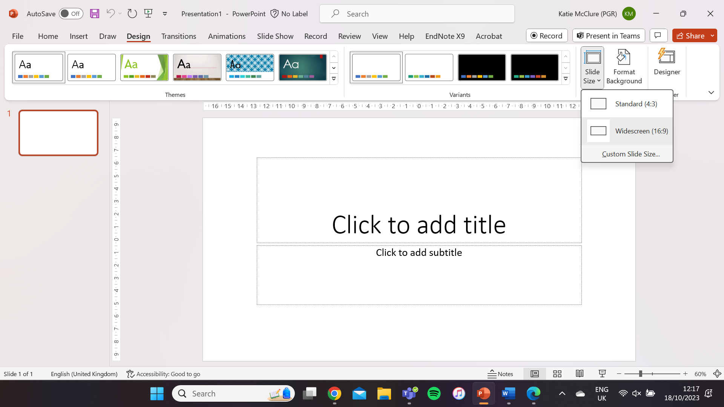 | 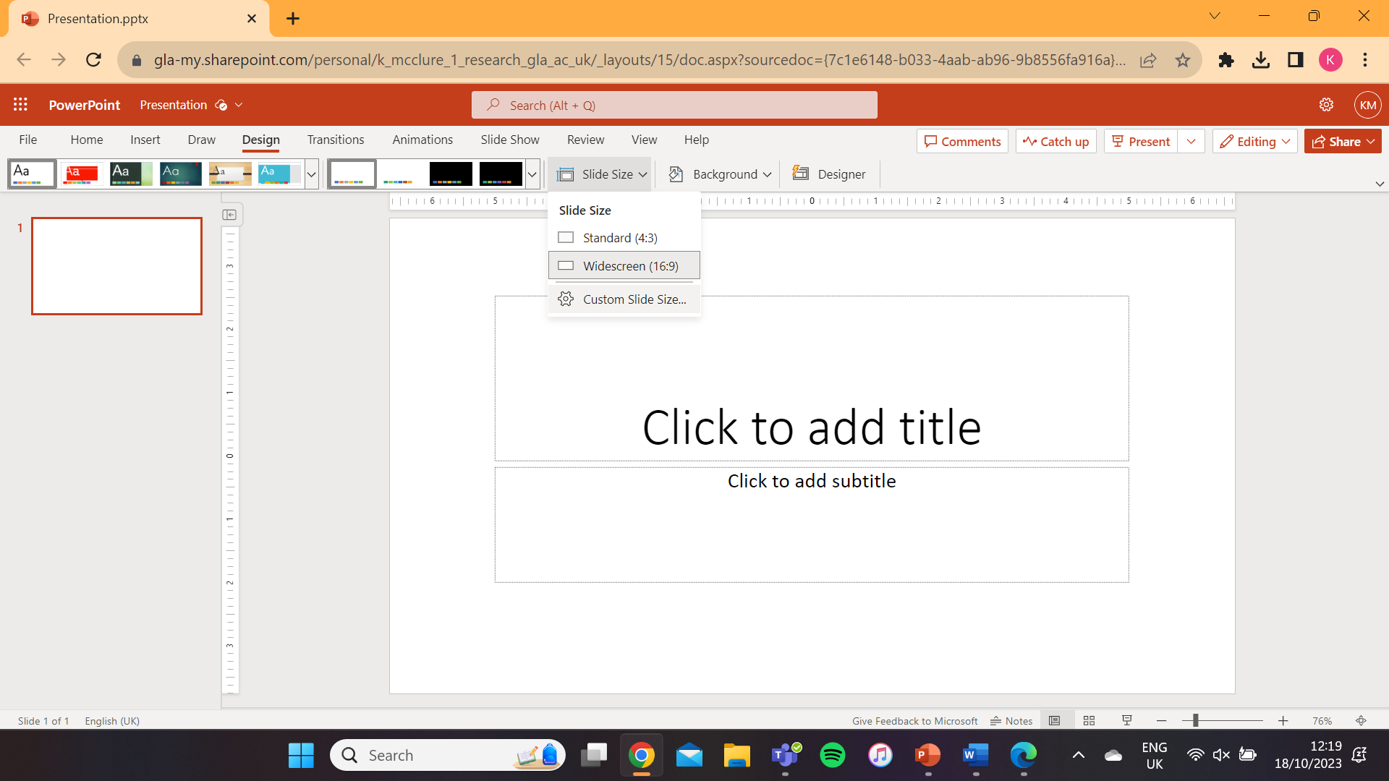
Desktop Version View | Web Version View

- Insert the desired size of your poster in the pop-up box.
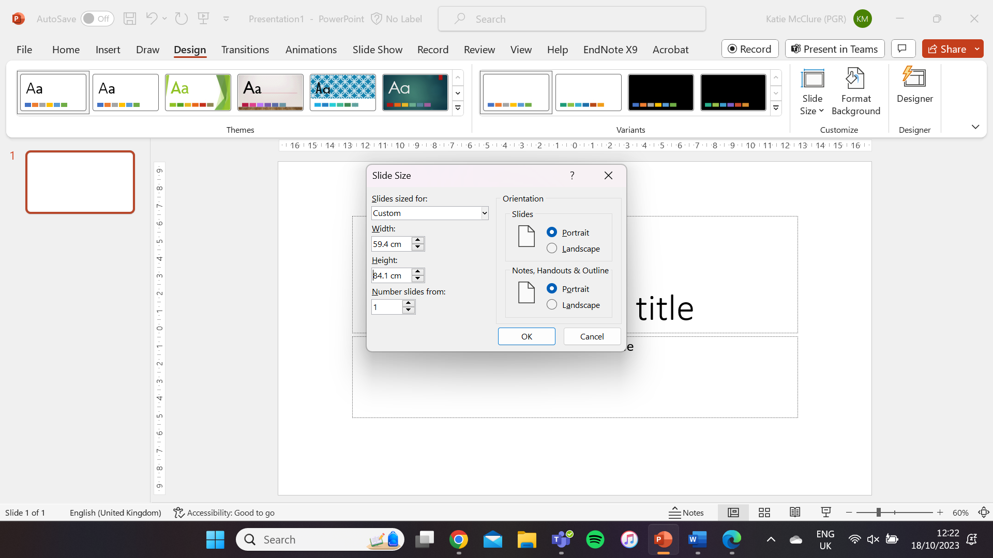 | 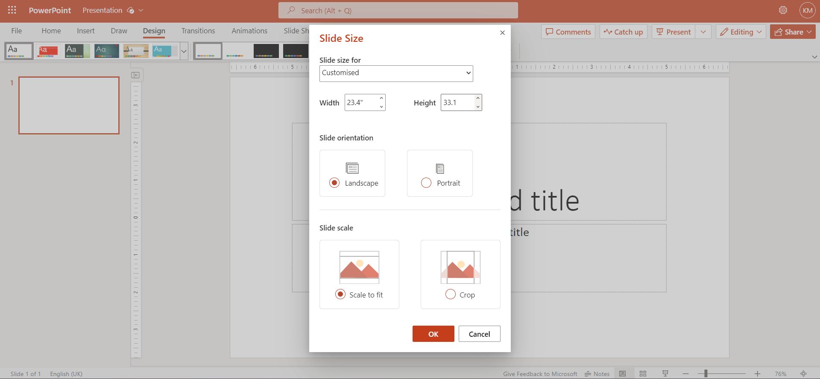
Desktop Version View | Web Version View

Some common poster on sizes:
Paper Size | Measurement (mm)
A0 | 841 x 1189
A1 | 594 x 841
A2 | 420 x 594
A3 | 297 x 420

- Add some textboxes using the Insert > Shapes tab to start your poster!
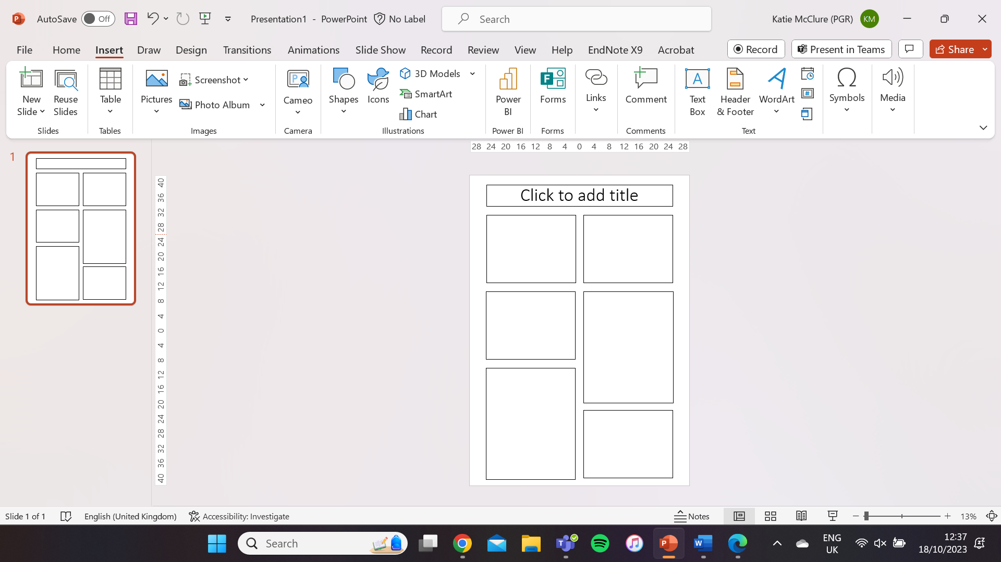 | 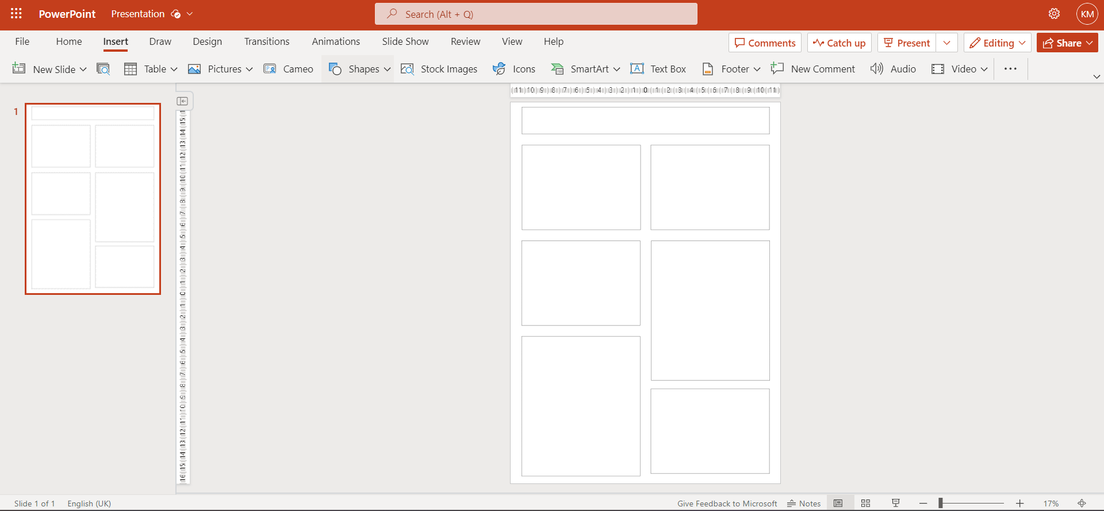
Desktop Version View | Web Version View

